**Math 252 Homework 2 Written Part Name:______________________________**

*Write legibly. Show your work. Graph neatly. Use a ruler for all straight lines.*

1. By reading values from the given graph of f, use five and then ten rectangles to find a lower estimate and an upper estimate for the area under the given graph from x=0 to x=10. In each case, carefully draw and shade the rectangles that you use.
   1. five rectangles, lower estimate:

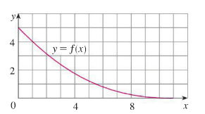

* 1. five rectangles, upper estimate:



* 1. ten rectangles, lower estimate:



* 1. ten rectangles, upper estimate:



1. Use six rectangles to find estimates of each type for the area under the given graph of f from x=0 to x=12. Carefully draw and shade the rectangles you use.
   1.  (left endpoints)

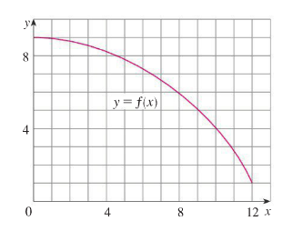

* 1.  (right endpoints)



* 1.  (midpoints)



* 1. Which of the three is a clear underestimate of the area under the curve?
  2. Which of the three is a clear overestimate of the area under the curve?
  3. Which of the three is the best estimate of the area under the curve?

1. The velocity graph of a braking car is shown. Use it to estimate the distance (include units) travelled by the car while the brakes are being applied. (Use .)

